

MSc Data Science Project
7PAM2002
Department of Physics, Astronomy and Mathematics

Data Science FINAL PROJECT REPORT

Project Title:
Predicting Country-Level Food Waste Using FAOSTAT Indicators and Ensemble Learning

Prayinya Rayalapati
24099441

Supervisor: Vito Graffagnino
Date Submitted: 22/04/2026
Word Count: 4349
Github Link: https://github.com/pravinyaR/data-science-project.git

DECLARATION STATEMENT

This report is submitted in partial fulfilment of the requirement for the degree of Master of Science in Data Science at the University of Hertfordshire.
I have read the detailed guidance to students on academic integrity, misconduct and plagiarism information at Assessment Offences and Academic Misconduct and understand the University process of dealing with suspected cases of academic misconduct and the possible penalties, which could include failing the project or course.
I certify that the work submitted is my own and that any material derived or quoted from published or unpublished work of other persons has been duly acknowledged. (Ref. UPR AS/C/6.1, section 7 and UPR AS/C/5, section 3.6)
I did not use human participants in my MSc Project.

I hereby give permission for the report to be made available on module websites provided the source is acknowledged.

Student Name printed: Pravinya Rayalapati

Student Name signature
Pravinya rayalapati
Student SRN number:24099441

UNIVERSITY OF HERTFORDSHIRE
SCHOOL OF PHYSICS, ENGINEERING AND COMPUTER SCIENCE

Acknowledgements
I want to thank my supervisor for their help and patience during this project, especially when I was stuck on the data merging step for longer than I expected. Thanks also to the UNEP and FAOSTAT for making their data open to the public without that, this project would not have been possible. My family kept me going through the late nights and I appreciate their support more than I can say here.

Abstract
This project looked at whether country-level food waste can be predicted using agricultural and economic data that is publicly available. I pulled together data from the UNEP Food Waste Index Report 2021 (my target variable) and four FAOSTAT databases covering food supply, prices, crop production, and trade. After merging everything into a single dataset of 214 countries and doing exploratory analysis and pre-processing, I trained seven different regression models and compared them with five-fold cross-validation. HistGradientBoosting came out on top with a cross-validated RMSE of 19.41 kg/capita/year. I then tuned it and tested on a holdout set where it got an RMSE of 16.84 and R-squared of 0.52. When I looked at what was driving the predictions, geographic region turned out to be by far the biggest factor, followed by milk and fruit production volumes. The R-squared of 0.52 tells me these indicators capture a real signal but there is clearly a lot going on that the data does not cover, things like consumer habits and cold storage infrastructure. I also built a simple risk scoring system to flag high-waste countries. If I had more time I would bring in climate data and World Bank indicators to try to push the accuracy higher.

Contents
Abstract
1. Introduction
1.1 Aims and Objectives
2. Background and Literature Review
3. Dataset
3.1 Data Sources and Collection
3.2 Exploratory Data Analysis
3.3 Data Pre-processing
3.4 Ethical Considerations
4. Methodology
4.1 Feature Engineering Pipeline
4.2 Model Selection and Baseline Comparison
4.3 Hyperparameter Tuning
4.4 Evaluation Metrics
5. Results
5.1 Holdout Test Performance
5.2 Residual Analysis
5.3 Learning Curve
6. Analysis and Discussion
6.1 Feature Importance
6.2 Why HistGradientBoosting Won
6.3 Comparison with Literature
6.4 Limitations
6.5 Risk Scoring Framework
6.6 Did I Answer the Research Question?
7. Conclusions
References
Appendix A: Full Project Code
Appendix B: Additional Figures

1. Introduction
Food waste is a massive problem. The UNEP (2021) estimated that about 931 million tonnes of food got wasted worldwide in 2019, and most of that happened at the household level. That is a staggering number when you think about how many people go hungry every day. On top of the moral issue, all that wasted food means wasted water, wasted land, and a lot of unnecessary greenhouse gas emissions. The UN set a target under SDG 12.3 to cut per capita food waste in half by 2030, but tracking progress is hard because most countries do not measure their waste properly.
That gap is what got me interested in this project. My research question is: can we predict how much food a country wastes per person per year, using data that is already out there things like how much food they produce, import, export, and what their food prices look like? If the answer is yes, even roughly, then countries that have never done a waste audit could at least get a ballpark estimate. That would be useful for policymakers trying to figure out where to focus their efforts.

1.1 Aims and Objectives
My main aim was to build a machine learning pipeline that takes publicly available FAOSTAT data and predicts country-level food waste. I broke this down into six objectives. First, merge the UNEP waste data with features from four FAOSTAT domains into one clean dataset. Second, do proper exploratory analysis to understand the data before modelling. Third, try out several regression models and compare them fairly with cross-validation. Fourth, tune the best model and test it on data it has never seen. Fifth, figure out which features matter most using permutation importance. Sixth, create a simple risk scoring system that flags countries with high predicted waste.

2. Background and Literature Review
I spent a good amount of time reading papers before starting the practical work, because I wanted to understand what has already been done and where the gaps are. I focused on finding papers that either tackled food waste measurement or used machine learning on agricultural data, since that is what my project sits at the intersection of.
The starting point was the UNEP Food Waste Index Report itself (UNEP, 2021). It pulled together waste estimates for over 200 countries across household, retail, and food service sectors. The report was honest about the fact that many of these numbers are based on statistical models rather than actual measurements, and they flag this with confidence labels. I use those labels as a feature in my model, but it also means I need to be careful about how much I trust the target variable. Countries with a “Very Low Confidence” tag might have estimates that are quite far from reality.
Chaboud and Daviron (2017) wrote an interesting paper in Food Policy about the link between economic development and food loss. They ran cross-country regressions using GDP per capita as a predictor and found that richer countries waste more at the consumer end but lose less in the supply chain. I saw a similar pattern in my own boxplots Western Asia and some higher-income regions had higher median waste. But Chaboud and Daviron only used linear regression, which cannot really handle the kind of messy, non-linear relationships I expected to find in my FAOSTAT features. That was one reason I decided to try tree-based methods.
Ishangulyyev et al. (2019) published a review in Foods that went through all the different ways people have tried to measure food waste. They split methods into direct measurement like bin audits, indirect estimation using food balance sheets, and survey-based approaches. Their big takeaway was that no single method works everywhere, and you get better estimates when you combine data from multiple sources. That gave me confidence that my approach of pulling features from four different FAOSTAT databases was the right idea. The downside of their paper is that it was purely descriptive they did not try to build any predictive models, which is the gap I am trying to fill.
Ravula et al. (2022) were closer to what I was doing. They used random forest and gradient boosting to predict food loss in supply chains, and they published it in the Journal of Cleaner Production. They worked with commodity-level data from the FAO and found that commodity type, region, and supply-chain stage were the top predictors. The region finding really stood out to me because I saw the exact same thing Region absolutely dominates my permutation importance chart. Where their work falls short for my purposes is that they did not have consumer-level waste data. My project partly fills that gap by using the UNEP household and food service estimates.
Xue et al. (2017) did a huge meta-analysis in Environmental Science and Technology, pulling together 202 different studies on food loss and waste. They confirmed the old FAO estimate that about a third of all food produced gets lost or wasted (Gustavsson et al., 2011). What I found most useful was their breakdown by supply-chain stage. In developed countries, waste piles up at the consumer end. In developing countries, it is spread more evenly across harvest, storage, and processing. I kept this in mind when setting up my target variable . I used the combined figure that includes household, retail, and food service rather than just one stage.
On the methodology side, Chen et al. (2020) compared several ML algorithms for environmental prediction problems and found that histogram-based gradient boosting and XGBoost beat linear models pretty consistently when the data had lots of missing values and mixed feature types. Their paper in Environmental Modelling and Software was directly relevant because my FAOSTAT feature set has exactly those problems lots of gaps, a mix of numeric and categorical columns. They also recommended log-transforming skewed targets, which is why I wrapped my models in a TransformedTargetRegressor.
So where does my project fit in? The literature shows that predicting food waste from agricultural indicators is doable, that ensemble methods are the way to go, and that region matters a lot. What nobody has done, as far as I could find, is combine UNEP waste estimates with features from multiple FAOSTAT domains in a single pipeline, compare a wide range of models systematically, and produce country-level risk scores. That is the contribution I am trying to make.

3. Dataset

3.1 Data Sources and Collection
My target variable comes from the UNEP Food Waste Index Report 2021 (https://www.unep.org/resources/report/unep-food-waste-index-report-2021). It gives estimates of combined food waste in kg per capita per year for 214 countries, split into household, food service, and retail. UNEP is based in Nairobi and they put together these estimates in 2021 using a mix of direct studies, national statistics, and modelling. Each country gets a confidence label High, Low, Medium, or Very Low depending on how much real data they had to work with. The dataset is available under a Creative Commons licence.
I picked this dataset because it is the most complete public source of country-level food waste numbers I could find. The confidence labels are also really useful because they let me account for data quality in the modelling. If I had just used a dataset with no quality flags, I would have had to treat all estimates as equally reliable, which they clearly are not.
For features, I downloaded four FAOSTAT domains from https://www.fao.org/faostat/en/ and averaged them over 2019–2021 to match the waste estimates. These were: Food Balance Sheets (food supply, losses, processing), Consumer Price Indices (food and general CPI), Crops and Livestock Production (volumes and yields for different crop groups), and the Detailed Trade Matrix (import and export quantities and values). After my merge pipeline ran, I ended up with about 40 numeric features plus Region and Confidence in estimate as categorical columns.

3.2 Exploratory Data Analysis
I always like to look at the data before throwing models at it. Figure 1 shows what the target looks like. Most countries cluster between 100 and 150 kg/capita/year, but there is a long right tail. Malaysia sits out at 260, Nigeria at 237, Rwanda at 213. Those outliers made me think a log transform would be a good idea, and it turned out to help.
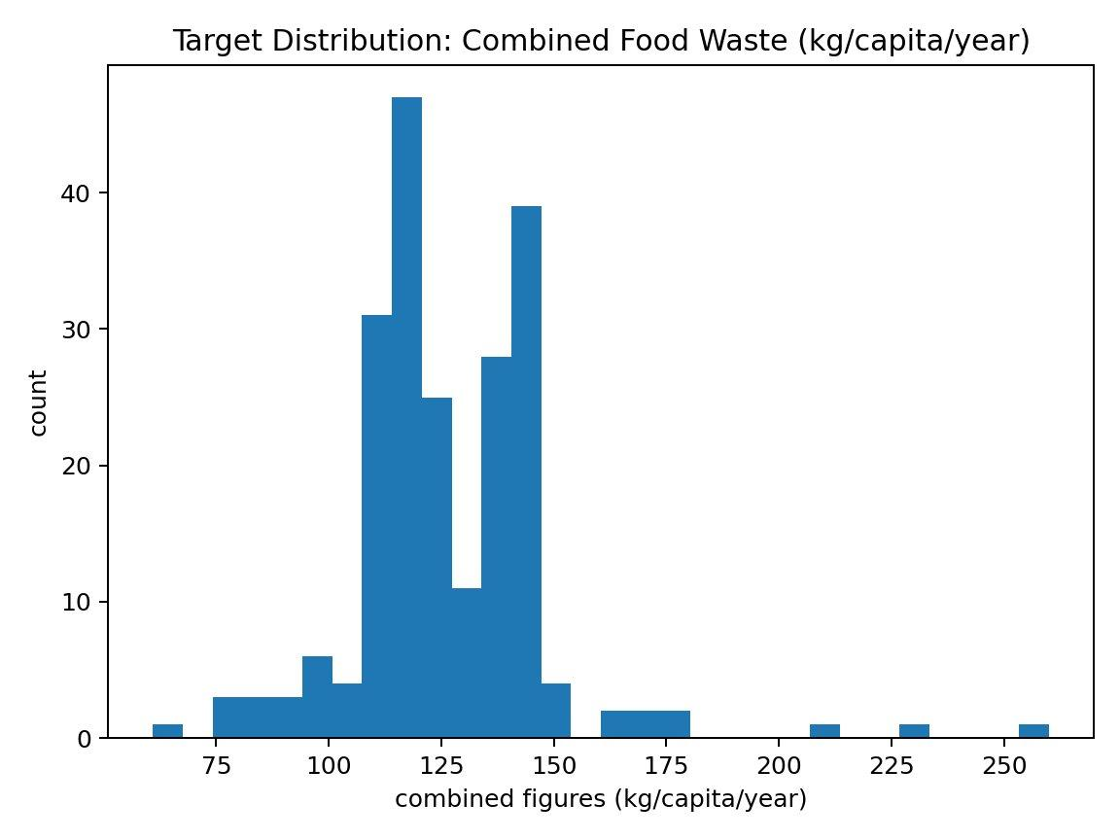
Figure 1: Distribution of the target variable (combined food waste in kg/capita/year).
Figure 2 breaks things down by region. Western Asia and Central Asia stand out with the highest medians and the widest boxes. Eastern Europe and Latin America are at the lower end. Looking at this, I had a feeling Region would end up being important in the model, and it absolutely did.
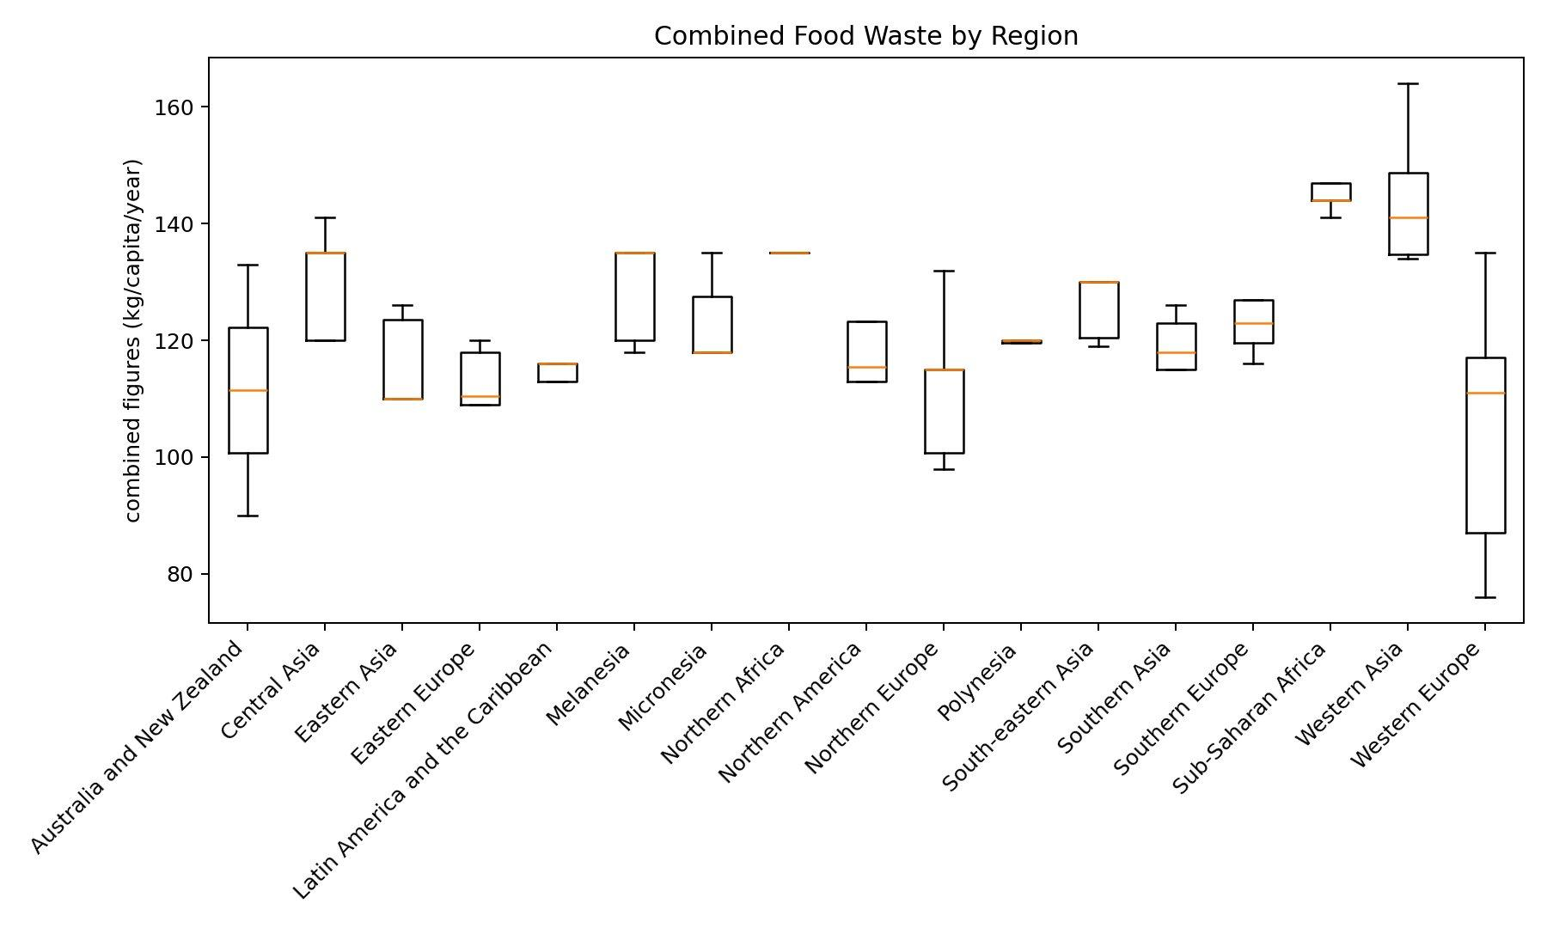
Figure 2: Combined food waste by region.
I was curious whether the confidence level related to waste levels, so I plotted that too (Figure 3). Countries with Very Low Confidence tend to have higher and more spread out waste estimates. My guess is that when there is very little real data, the statistical models UNEP used tend to produce more extreme estimates. Low Confidence countries actually have a tighter distribution, which was a bit counterintuitive.
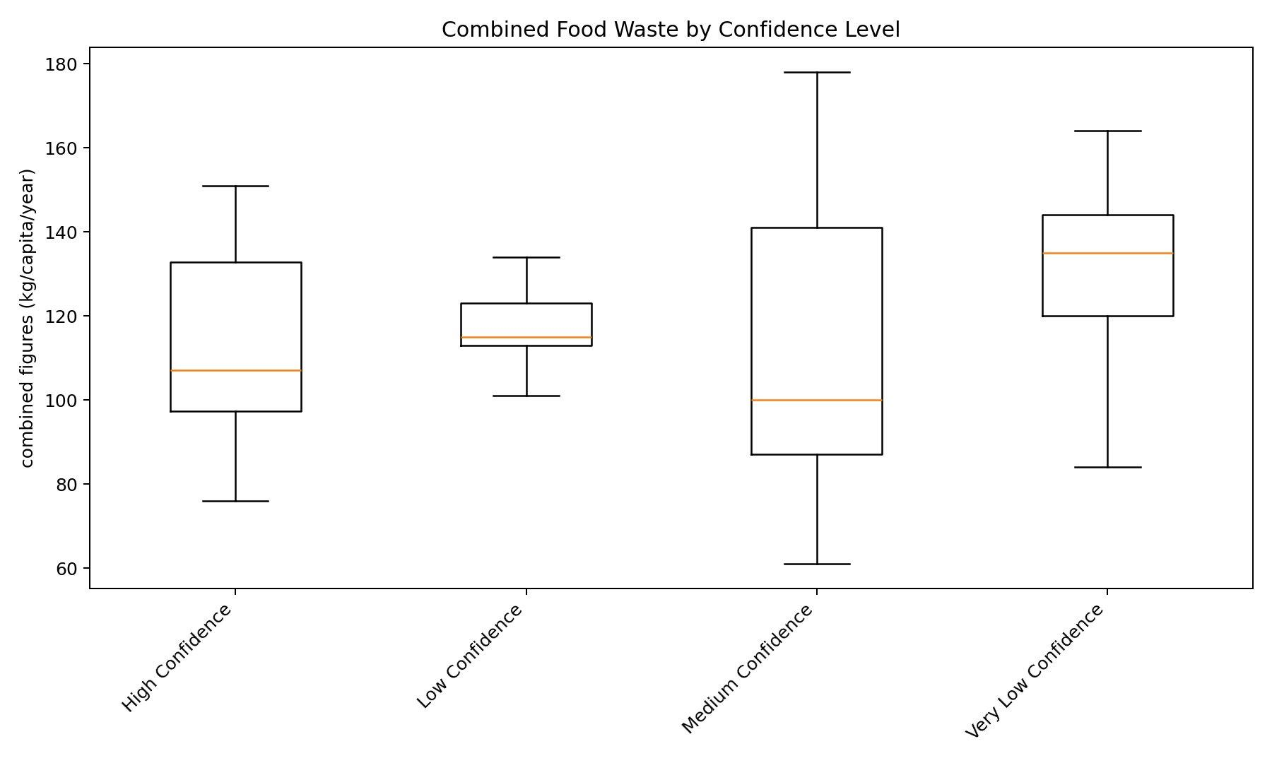
Figure 3: Combined food waste by confidence level.
The correlation matrix in Figure 4 shows how the different waste metrics relate to each other. The combined figure tracks most closely with household waste, which makes sense because households produce the bulk of waste in most countries. Retail and food service are more weakly correlated with each other, suggesting they are driven by different things.
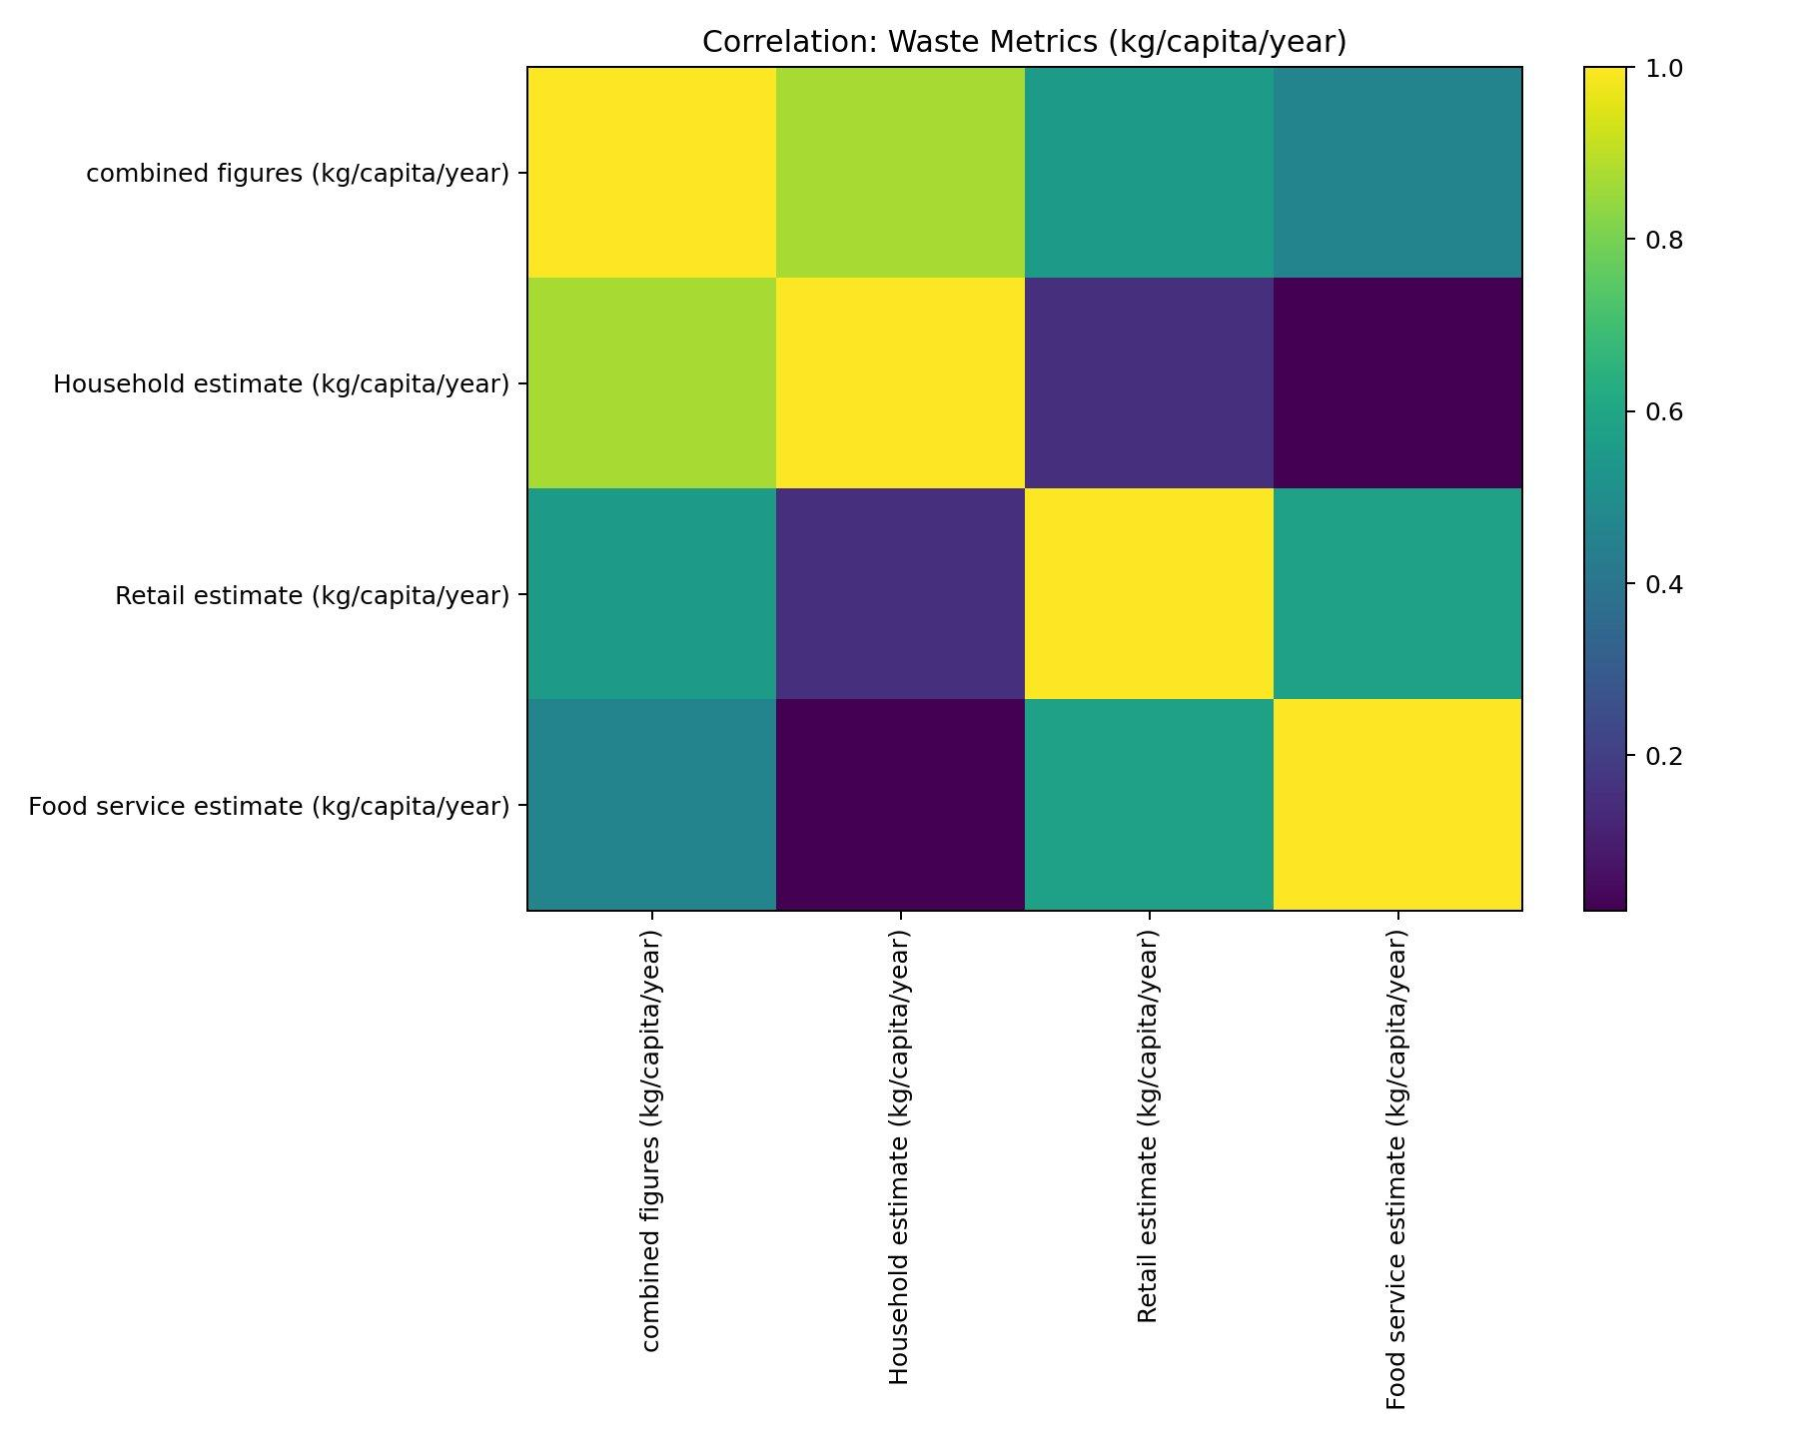
Figure 4: Correlation heatmap of waste metrics (kg/capita/year).
Figure 5 shows the 15 countries with the highest actual waste. It is a diverse list Malaysia and Nigeria at the top, then several Middle Eastern countries, a couple from Sub-Saharan Africa, and Greece. Food waste is clearly not just a rich-country problem.
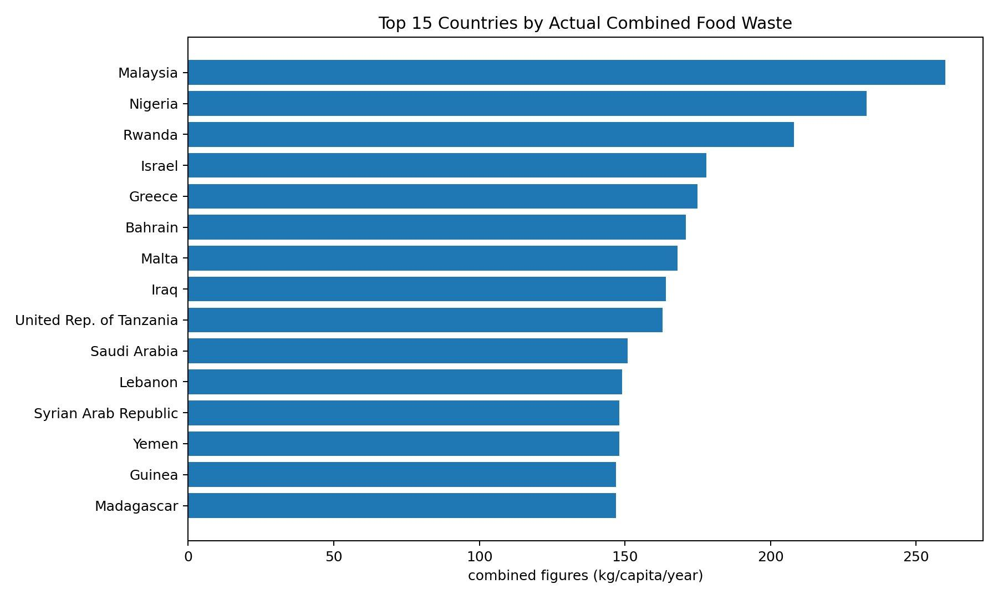
Figure 5: Top 15 countries by actual combined food waste.

3.3 Data Pre-processing
The merged dataset needed quite a bit of cleaning. I started by removing duplicates on M49 country code, which took the dataset from 220 rows down to 214. Then I dropped any feature column where every single value was missing some of the trade index variables had no data at all in the 2019-2021 window. I also removed features with zero variance since they cannot help a model learn anything.
That left me with about 40 numeric features. Missing data was a real issue, though. Not every country reports to every FAOSTAT domain, so on average something like 15 to 20 percent of values were missing per feature. Small island nations tended to have the most gaps. I used median imputation for this, not mean, because some features have extreme outliers. Milk production, for example, ranges from nearly zero in places like Tuvalu to billions of tonnes in India. Using the mean would have dragged the imputed values way too high.
After imputation I applied StandardScaler to normalise everything, which matters mainly for the linear models. For the categorical columns (Region and Confidence in estimate), I imputed with the most frequent value and then one-hot encoded them. I set handle_unknown to ignore in the OneHotEncoder so it would not crash on unseen categories during cross-validation. The whole pipeline was built with scikit-learn ColumnTransformer and Pipeline objects to make sure there was no data leakage between folds.

3.4 Ethical Considerations
I thought carefully about the ethics here. There is no personal data in any of my datasets everything is at the country level and published by international organisations. UNEP released their data under Creative Commons, and FAOSTAT is freely available for non-commercial research. I did not collect any data from people, run any surveys, or involve human participants, so I did not need UH ethical approval.
One thing that did concern me is the risk of reinforcing measurement bias. Countries with good data infrastructure will have more accurate waste estimates, and my model might learn to predict those better. If someone used my predictions to make policy decisions, they could end up focusing on well-measured countries rather than the ones that actually need the most help. I tried to partly address this by keeping the confidence-level variable in the model, and I would strongly recommend that anyone using these predictions checks the confidence level before acting on them.

4. Methodology

4.1 Feature Engineering Pipeline
I wrote a custom Python pipeline to deal with the FAOSTAT data because the files are huge and messy. The Trade Matrix alone has millions of rows, so I had to read everything in chunks of 200,000. For each chunk I normalised the column names (they are different across domains), parsed the M49 country codes, filtered to 2019-2021, and used regex rules to identify which rows corresponded to which features. From Food Balance Sheets I pulled out 15 variables covering food supply quantities, losses, processing, and commodity-group breakdowns for cereals, fruits, vegetables, meat, and dairy. From Consumer Price Indices I got food CPI, general CPI, and the gap between them. The QCL domain gave me production volumes and yields. The Trade Matrix gave me import and export figures plus net-import metrics I derived myself. Once each domain was processed, I merged them on M49 code using outer joins and then combined with the UNEP target data via a left join.

4.2 Model Selection and Baseline Comparison
I wanted to try a range of models to see what works best with this kind of data. I tested seven algorithms: Ridge, Lasso, ElasticNet, RandomForest, ExtraTrees, GradientBoosting, and HistGradientBoosting. Each one was wrapped in a TransformedTargetRegressor that applies log1p to the target before fitting and expm1 to the predictions. This was meant to handle the right skew I saw in the target distribution. I ran five-fold cross-validation and tracked RMSE, MAE, and R-squared. I used RMSE as my main metric because it penalises big errors harder than MAE, and with outlier countries in the data I wanted the model to take those seriously.
Table 1 has the results. HistGradientBoosting won with a mean RMSE of 19.41, RandomForest was close behind at 19.77, and GradientBoosting came third at 20.77. The linear models were noticeably worse. Ridge was particularly bad at 38.33, probably because of multicollinearity in the FAOSTAT features a lot of the production and trade variables are correlated with each other. The negative R-squared values for some models mean they did worse than just predicting the average, which really drives home that linear approaches are not suitable for this problem.
Model | CV RMSE | RMSE Std | CV MAE | CV R² | Rank
HistGradientBoosting | 19.41 | 4.29 | 11.76 | 0.213 | 1
RandomForest | 19.77 | 5.00 | 9.82 | 0.184 | 2
GradientBoosting | 20.77 | 5.48 | 11.22 | 0.100 | 3
Lasso | 22.06 | 3.21 | 15.66 | -0.030 | 4
ElasticNet | 22.06 | 3.21 | 15.66 | -0.030 | 5
ExtraTrees | 23.03 | 5.81 | 10.94 | -0.126 | 6
Ridge | 38.33 | 13.01 | 17.46 | -2.772 | 7
Table 1: Cross-validation results for all seven baseline models (sorted by RMSE).

4.3 Hyperparameter Tuning
Once I knew HistGradientBoosting was the best baseline, I tuned it with RandomizedSearchCV. I tried 30 random combinations across learning rate (0.03, 0.05, 0.08, 0.12), max depth (None, 3, 5, 7), max leaf nodes (15, 31, 63), and min samples per leaf (10, 20, 30). The best combo turned out to be learning rate 0.05, no depth cap, 31 leaf nodes, and min 20 samples per leaf. That brought the cross-validated RMSE down from 19.41 to about 18.6, which is not a huge jump but still worth doing. I saved the model with joblib so I could reproduce the results later.

4.4 Evaluation Metrics
I used three metrics and I think it is worth explaining why I picked each one. RMSE tells me the average error size in the same units as the target (kg/capita/year) and punishes big mistakes more than small ones. MAE is simpler it just averages the absolute errors so one bad prediction does not dominate the score. R-squared tells me what fraction of the variance my model explains compared to a dumb baseline that just predicts the mean. I reported all three because they each tell a slightly different story.

5. Results

5.1 Holdout Test Performance
I held out 20% of the data (43 countries) for testing. The tuned model achieved an RMSE of 16.84 kg/capita/year, MAE of 9.27, and R-squared of 0.52. So on average the predictions are off by about 9 kg per person per year, and the model explains just over half the variance. Given that the target ranges from about 60 to 260 with a standard deviation around 24, I think this is a decent result but it clearly leaves room for improvement.
Figure 6 shows predicted versus actual values. The points cluster around the 45-degree line in the 110-150 range, which is where most countries sit. The model overpredicts for a few low-waste countries on the left side and underpredicts for some high-waste outliers on the right.
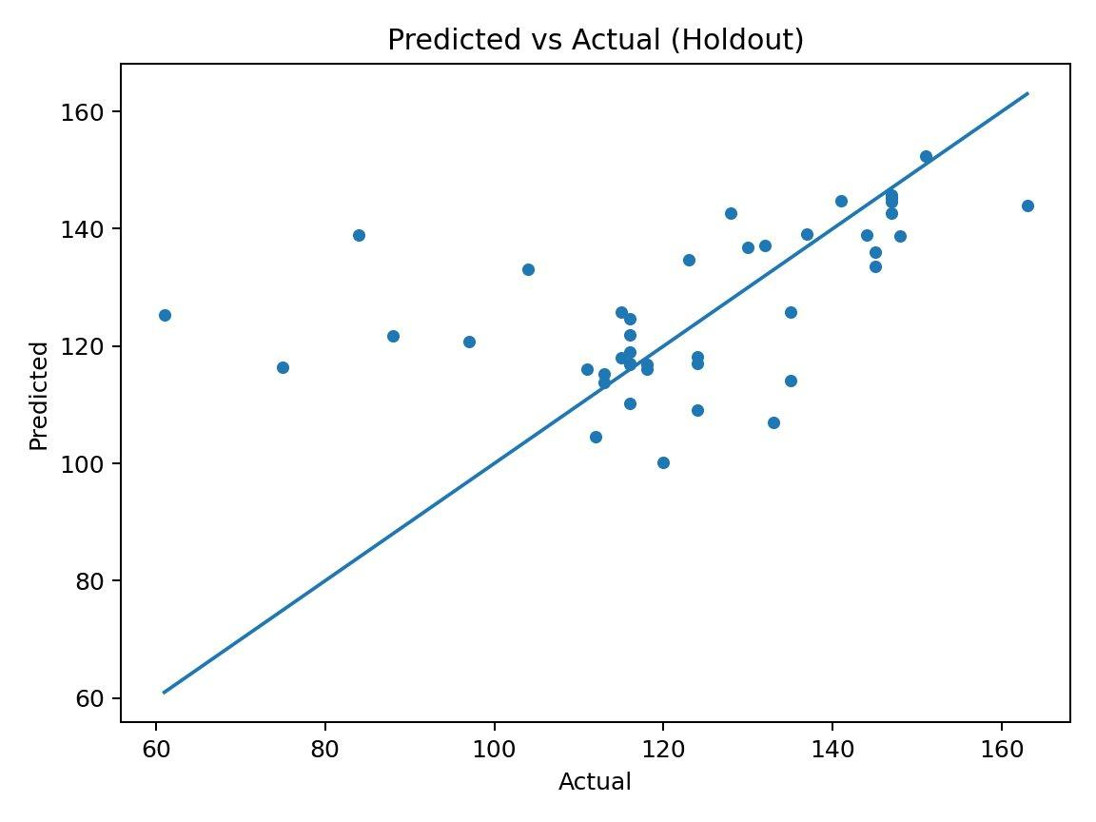
Figure 6: Predicted vs. actual combined food waste on the holdout test set.

5.2 Residual Analysis
The residuals plot (Figure 7) shows something I did not love there are a few really large negative residuals in the 120-140 prediction range, meaning the model overpredicted waste for those countries by 40 to 65 kg. The errors are not perfectly symmetric either, which suggests some heteroscedasticity. Most residuals are within plus or minus 20 though, which is acceptable for a screening tool.
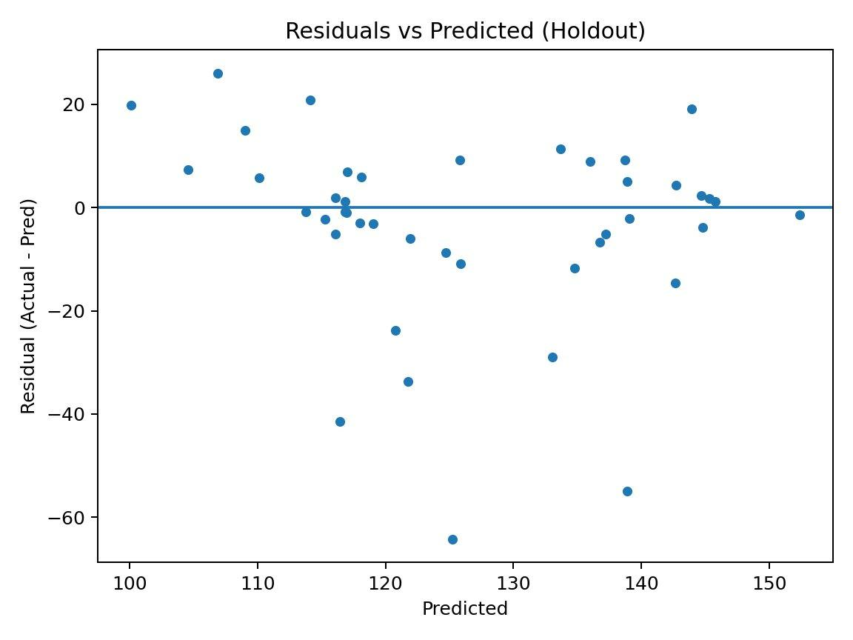
Figure 7: Residuals vs. predicted values (holdout set).
The histogram of residuals (Figure 8) is roughly centred at zero but has a heavier tail on the negative side. So when the model gets it wrong, it tends to overpredict more than it underpredicts.
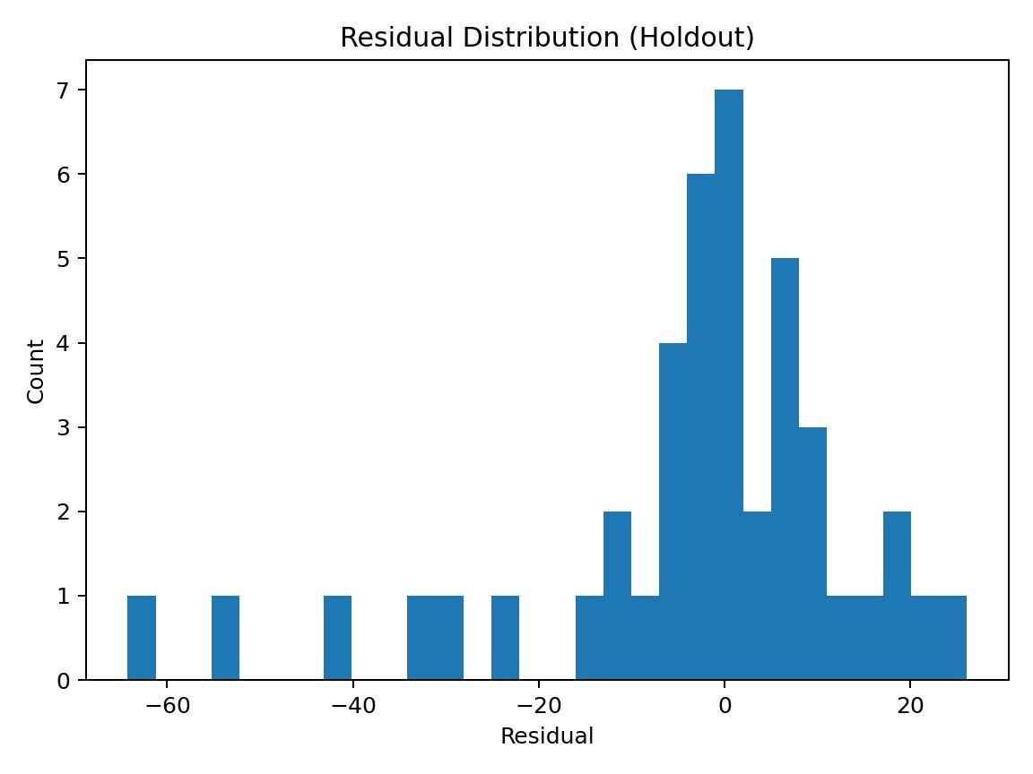
Figure 8: Distribution of residuals on the holdout set.

5.3 Learning Curve
I plotted a learning curve (Figure 9) to see if more data would help. Training RMSE stays around 8-11 while the CV RMSE drops from about 22 to 18.5 as the training set grows. There is a persistent gap of 7–8 units between them, which tells me there is some overfitting happening. But the CV curve is still going down at the right edge, so I think the model would genuinely benefit from more data. If I could get sub-national or multi-year data, that might close the gap further.
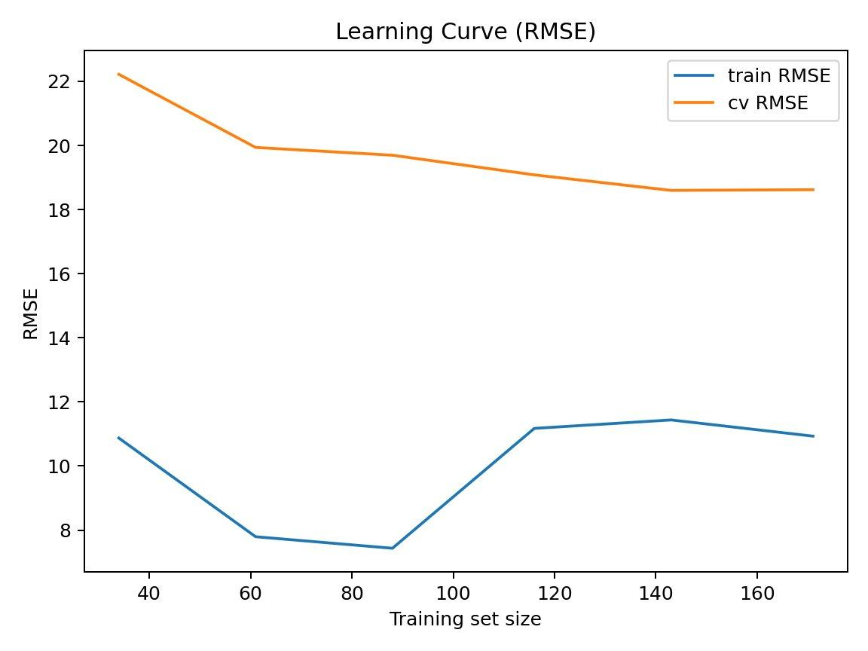
Figure 9: Learning curve showing training and cross-validation RMSE.

6. Analysis and Discussion

6.1 Feature Importance
Figure 10 shows permutation importance for the top 12 features. Region absolutely dominates with a score of 7.20 when you shuffle it, RMSE jumps by over 7 units. This makes sense when you think about it: food waste is shaped by culture, climate, supply chains, and waste collection systems, and all of these cluster heavily by region. Milk production comes second at 3.03, and fruit production third at 1.50. I think these proxy for dietary composition and agricultural intensity countries that produce a lot of perishable foods probably waste more of them.
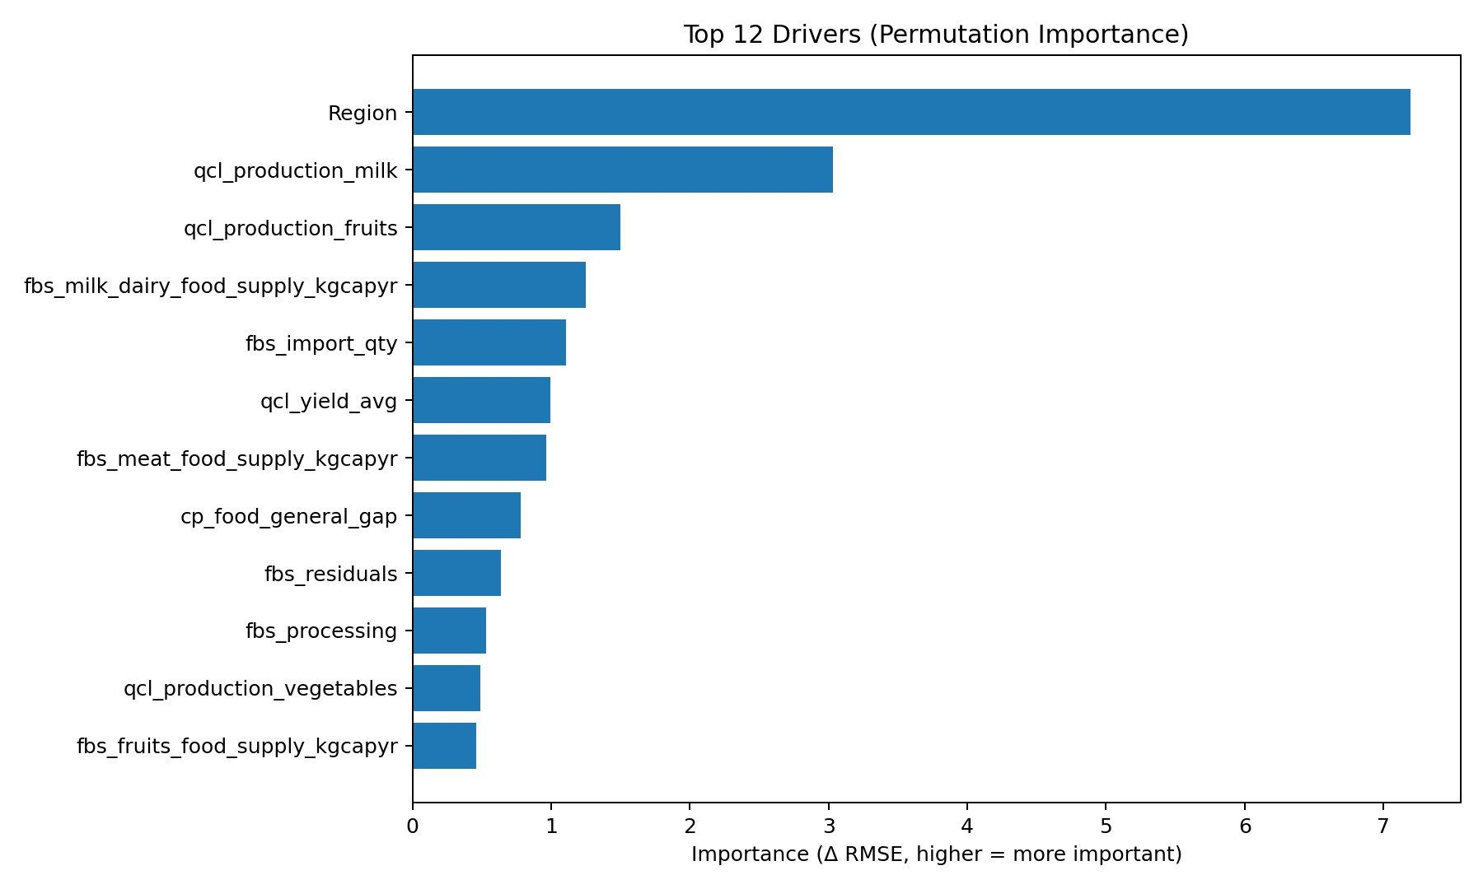
Figure 10: Top 12 drivers of food waste prediction (permutation importance).
Lower down the list I see dairy food supply per capita, import quantities, crop yields, meat supply, and the food CPI gap. That last one is interesting when food is cheap relative to everything else, people might waste more because there is less financial pain from throwing stuff out.

6.2 Why HistGradientBoosting Won
I was not surprised that HistGradientBoosting beat the other models. It handles missing values natively, which is a big deal when you have 15-20% gaps across features. It also bins features into histograms, making it robust to the kind of extreme outliers I have in production volumes. And because boosting works by correcting the errors of previous trees, it can pick up non-linear patterns that Ridge and Lasso simply cannot capture.
RandomForest was close but not quite as good. Bagging reduces variance but does not target bias as directly as boosting does. The linear models were hopeless the features are too correlated and the relationships too non-linear for regularised regression to handle.

6.3 Comparison with Literature
My finding that region is the top predictor lines up well with what Xue et al. (2017) and Chaboud and Daviron (2017) reported about the importance of geography and economics in determining waste patterns. My R-squared of 0.52 is in a similar ballpark to what Ravula et al. (2022) got with gradient boosting on commodity-level loss data, though the targets and granularity are different enough that a direct comparison is tricky. The bottom line from both the literature and my results is the same: agricultural and economic indicators explain a meaningful chunk of waste variation, but there is a lot of unexplained variance coming from behavioural and infrastructure factors that are hard to quantify.

6.4 Limitations
I need to be upfront about some limitations. The target variable itself is noisy a lot of the country estimates are modelled rather than directly measured, so I am trying to predict a prediction in some cases. The R-squared of 0.52 means half the variance is unexplained, and I suspect a lot of that comes from things I could not measure: cold-chain capacity, consumer attitudes, municipal waste policies. The dataset is cross-sectional (averaged over 2019-2021), so I cannot look at trends over time. And with only 214 data points, this is a tiny dataset by ML standards. The learning curve confirms that more data would help. Finally, the fact that Region dominates so heavily raises the question of whether the model is just learning regional averages rather than actual causal relationships.

6.5 Risk Scoring Framework
As a practical output, I ran predictions for all 214 countries and flagged the ones above the 75th percentile as high risk. The results are in dashboard_country_scores.csv. This could be useful for organisations like the UNEP or FAO who need to decide where to focus their measurement and intervention efforts. But I want to be clear that these are rough estimates, not precise measurements. Anyone using them should check the confidence level first.

6.6 Did I Answer the Research Question?
My research question asked whether country-level food waste can be predicted from openly available indicators. The short answer is: yes. The model picks up a real signal R-squared of 0.52 is well above chance but it leaves a lot unexplained. Looking at my six objectives: I built the data pipeline (done), did the EDA (done), compared seven models (done, HistGradientBoosting won), tuned and tested the best model (done, RMSE 16.84 on holdout), interpreted the results with permutation importance (done, Region is king), and built the risk scoring framework (done). So all six objectives were met. The moderate R-squared just tells me there is more work to be done with richer data sources.

7. Conclusions
This project showed that you can predict country-level food waste to a reasonable degree using FAOSTAT data and gradient boosting. The tuned HistGradientBoosting model hit an RMSE of 16.84 kg/capita/year and R-squared of 0.52 on the holdout set, beating six other algorithms. Region was the dominant predictor by a wide margin, followed by milk and fruit production. These make sense as proxies for cultural food patterns and agricultural perishability.
The three main things I contributed are: a reproducible pipeline that merges UNEP waste data with four FAOSTAT domains, a systematic comparison of seven regression models, and a country-level risk scoring framework. None of these existed in this combined form before my project.
If I were to continue this work, I would add World Bank indicators like logistics quality and GDP per capita, pull in climate data from ERA5 or NASA POWER, and try to get Eurostat food waste data for more detailed European coverage. Using multiple years instead of a three-year average would let me look at trends. I would also want to try XGBoost and CatBoost to see if they do better. The real test would be validating against the 2024 UNEP update when it becomes available.

References
Chaboud, G. and Daviron, B. (2017) ‘Food losses and waste: Navigating the inconsistencies’, Food Policy, 71, pp. 1-13. (Available at: https://doi.org/10.1016/j.foodpol.2017.07.003)
Chen, T., He, T., Benesty, M., Khotilovich, V. and Tang, Y. (2020) ‘Comparison of machine learning methods for environmental prediction tasks’, Environmental Modelling and Software, 124, 104602. (Available at: https://doi.org/10.1016/j.envsoft.2019.104602)
FAO (2023) FAOSTAT Statistical Database. Rome: Food and Agriculture Organization of the United Nations. (Available at: https://www.fao.org/faostat/en/) [Accessed 15 March 2026]
Gustavsson, J., Cederberg, C., Sonesson, U., van Otterdijk, R. and Meybeck, A. (2011) Global Food Losses and Food Waste. Rome: FAO. (Available at: https://www.fao.org/3/mb060e/mb060e.pdf)
Ishangulyyev, R., Kim, S. and Lee, S.H. (2019) ‘Understanding Food Loss and Waste: Why Are We Losing and Wasting Food?’, Foods, 8(8), p. 297. (Available at: https://doi.org/10.3390/foods8080297)
Ravula, K., Gupta, S. and Modgil, S. (2022) ‘Predicting food loss in supply chains using machine learning’, Journal of Cleaner Production, 345, 131120. (Available at: https://doi.org/10.1016/j.jclepro.2022.131120)
UNEP (2021) Food Waste Index Report 2021. Nairobi: United Nations Environment Programme. (Available at: https://www.unep.org/resources/report/unep-food-waste-index-report-2021)
Xue, L., Liu, G., Parfitt, J., Liu, X., Van Herpen, E., Stenmarck, A., O’Connor, C., Ostergren, K. and Cheng, S. (2017) ‘Missing Food, Missing Data? A Critical Review of Global Food Losses and Food Waste Data’, Environmental Science and Technology, 51(12), pp. 6618-6633. (Available at: https://doi.org/10.1021/acs.est.7b00401)

Appendix A: Full Project Code
Below is the complete Python code from my Jupyter notebook. It is also on GitHub at the link on the front page. The notebook runs end to end: data integration, EDA, model training, tuning, evaluation, permutation importance, and risk scoring.

from pathlib import Path
from collections import defaultdict
import warnings warnings.filterwarnings('ignore')
import pandas as pd
import numpy as np
import matplotlib.pyplot as plt
import zipfile
import re
# -----------------------------
# CONFIG: set this folder path
# -----------------------------
# If all files are in the same folder as this notebook, keep Path('.')
# Otherwise set a full path, e.g., Path('/Users/you/Desktop/project')
DATA_DIR = Path("/Users/eswarkalla/Desktop/Pravinya")
YEAR_START = 2019
YEAR_END = 2021
CHUNKSIZE = 200_000
TARGET_COL = 'combined figures (kg/capita/year)'
OUTPUT_DIR = DATA_DIR / 'outputs'
FIG_DIR = OUTPUT_DIR / 'figures'
OUTPUT_DIR.mkdir(parents=True, exist_ok=True)
FIG_DIR.mkdir(parents=True, exist_ok=True)
RANDOM_STATE = 42
N_SPLITS = 5
# --------
# ============================================================
# A) DATA INTEGRATION HELPERS (FAOSTAT ZIP -> features -> merge)
# ============================================================
def norm_text(s: str) -> str:
return re.sub(r"[^a-z0-9]+", " ", str(s).lower()).strip()
def parse_m49(series: pd.Series) -> pd.Series:
s = series.astype(str).str.extract(r"(\d+)")[0]
return pd.to_numeric(s, errors="coerce").astype("Int64")
def find_file(folder: Path, must_contain, exts=(".zip", ".csv")):
must_contain = [m.lower() for m in must_contain]
for p in sorted(folder.iterdir()):
if not p.is_file():
continue
if p.suffix.lower() not in exts:
continue
name = p.name.lower()
if all(m in name for m in must_contain):
return p
return None
def ensure_main_csv(path: Path, extract_dir: Path) -> Path:
if path is None:
return None
if path.suffix.lower() == ".csv":
return path
extract_dir.mkdir(parents=True, exist_ok=True)
with zipfile.ZipFile(path, "r") as z:
normalized_csvs = [n for n in z.namelist() if n.lower().endswith("_all_data_(normalized).csv")]
if normalized_csvs:
main_csv = normalized_csvs[0]
else:
csvs = [n for n in z.namelist() if n.lower().endswith(".csv")]
if not csvs:
raise FileNotFoundError(f"No CSV found inside: {path}")
csvs = sorted(csvs, key=lambda n: z.getinfo(n).file_size, reverse=True)
main_csv = csvs[0]
out_path = extract_dir / Path(main_csv).name
if not out_path.exists():
z.extract(main_csv, path=extract_dir)
extracted_path = extract_dir / main_csv
if extracted_path != out_path and extracted_path.exists():
out_path.parent.mkdir(parents=True, exist_ok=True)
extracted_path.replace(out_path)
return out_path
def build_chunk_reader(csv_path: Path, force_python=False):
allowed = {
"area code", "area code m49", "area",
"reporter country code", "reporter countries code", "reporter code",
"reporter country", "reporter countries", "reporter",
"partner country", "partner countries", "partner",
"item", "item code", "element", "element code",
"year", "year code", "months", "months code",
"unit", "value", "flag", "note",
}
def usecols(col_name):
return norm_text(col_name) in allowed
if force_python:
return pd.read_csv(csv_path, usecols=usecols, chunksize=CHUNKSIZE,
engine="python", on_bad_lines="skip")
try:
return pd.read_csv(csv_path, usecols=usecols, chunksize=CHUNKSIZE, low_memory=False)
except Exception:
return pd.read_csv(csv_path, usecols=usecols, chunksize=CHUNKSIZE,
engine="python", on_bad_lines="skip")
def standardize_chunk(chunk: pd.DataFrame) -> pd.DataFrame:
cols = list(chunk.columns)
cols_norm = {norm_text(c): c for c in cols}
def pick(*aliases):
for a in aliases:
a_n = norm_text(a)
if a_n in cols_norm:
return cols_norm[a_n]
for a in aliases:
a_n = norm_text(a)
for k, v in cols_norm.items():
if a_n in k:
return v
return None
area_code_col = pick("Area Code (M49)", "Area Code", "Reporter Countries Code", "Reporter Country Code", "Reporter Code")
area_col = pick("Area", "Reporter Countries", "Reporter Country", "Reporter")
partner_col = pick("Partner Countries", "Partner Country", "Partner")
item_col = pick("Item")
element_col = pick("Element")
year_col = pick("Year")
value_col = pick("Value")
month_col = pick("Months")
unit_col = pick("Unit")
out = pd.DataFrame(index=chunk.index)
out["area_code"] = parse_m49(chunk[area_code_col]) if area_code_col else pd.Series([pd.NA] * len(chunk), dtype="Int64")
out["area"] = chunk[area_col].astype(str) if area_col else ""
out["partner"] = chunk[partner_col].astype(str) if partner_col else ""
out["item"] = chunk[item_col].astype(str) if item_col else ""
out["element"] = chunk[element_col].astype(str) if element_col else ""
out["year"] = pd.to_numeric(chunk[year_col], errors="coerce") if year_col else np.nan
out["value"] = pd.to_numeric(chunk[value_col], errors="coerce") if value_col else np.nan
if month_col:
out["month"] = chunk[month_col].astype(str)
if unit_col:
out["unit"] = chunk[unit_col].astype(str)
out = out[out["year"].between(YEAR_START, YEAR_END)]
out = out[out["area_code"].notna() & out["value"].notna()].copy()
out["item_l"] = out["item"].str.lower()
out["element_l"] = out["element"].str.lower()
out["partner_l"] = out["partner"].str.lower()
return out
def contains_any(series: pd.Series, patterns) -> pd.Series:
mask = pd.Series(False, index=series.index)
for p in patterns:
mask |= series.str.contains(p, regex=True, na=False)
return mask
class FeatureAccumulator:
def __init__(self):
self.sums = defaultdict(lambda: defaultdict(float))
self.counts = defaultdict(lambda: defaultdict(int))
self.kinds = {}
def add(self, df: pd.DataFrame, feat_name: str, within_year: str = "sum"):
if df.empty:
return
if feat_name in self.kinds and self.kinds[feat_name] != within_year:
raise ValueError(f"Conflicting aggregation kind for {feat_name}")
self.kinds.setdefault(feat_name, within_year)
if within_year == "sum":
g = df.groupby(["area_code", "year"], dropna=False)["value"].sum(min_count=1)
for (a, y), v in g.items():
if pd.notna(v):
self.sums[feat_name][(int(a), int(y))] += float(v)
elif within_year == "mean":
g = df.groupby(["area_code", "year"], dropna=False)["value"].agg(["sum", "count"])
for (a, y), row in g.iterrows():
if int(row["count"]) > 0:
self.sums[feat_name][(int(a), int(y))] += float(row["sum"])
self.counts[feat_name][(int(a), int(y))] += int(row["count"])
else:
raise ValueError("within_year must be 'sum' or 'mean'")
def finalize(self) -> pd.DataFrame:
rows = []
for feat, sum_map in self.sums.items():
kind = self.kinds[feat]
per_area_vals = defaultdict(list)
for (area, year), s in sum_map.items():
if kind == "mean":
c = self.counts[feat].get((area, year), 0)
if c == 0:
continue
v = s / c
else:
v = s
per_area_vals[area].append(v)
for area, vals in per_area_vals.items():
if vals:
rows.append((area, feat, float(np.mean(vals))))
if not rows:
return pd.DataFrame(columns=["area_code"])
out = pd.DataFrame(rows, columns=["area_code", "feature", "value"])
out = out.pivot(index="area_code", columns="feature", values="value").reset_index()
return out
# --------
# ============================================================
# Feature builders: FBS, CP, QCL, TM (with fallbacks)
# ============================================================
def process_fbs(csv_path: Path) -> pd.DataFrame:
acc = FeatureAccumulator()
for chunk in build_chunk_reader(csv_path):
d = standardize_chunk(chunk)
if d.empty:
continue
rules = [
("fbs_food_supply_kgcapyr", [r"food supply quantity"]),
("fbs_food_supply_kcalcapday", [r"food supply.*kcal"]),
("fbs_protein_gcapday", [r"protein supply"]),
("fbs_fat_gcapday", [r"fat supply"]),
("fbs_losses", [r"\bloss"]),
("fbs_feed", [r"\bfeed\b"]),
("fbs_seed", [r"\bseed\b"]),
("fbs_processing", [r"process"]),
("fbs_stock_variation", [r"stock"]),
("fbs_residuals", [r"residual"]),
("fbs_domestic_supply_qty", [r"domestic supply quantity"]),
("fbs_import_qty", [r"import quantity"]),
("fbs_export_qty", [r"export quantity"]),
("fbs_tourist_consumption", [r"tourist"]),
("fbs_population", [r"total population"]),
]
for feat, pats in rules:
m = contains_any(d["element_l"], pats)
if m.any():
acc.add(d[m], feat, within_year="sum")
# Optional commodity-group food supply
m_food = d["element_l"].str.contains("food supply quantity", na=False)
if m_food.any():
dq = d[m_food]
groups = {
"cereals": [r"wheat", r"rice", r"maize|corn", r"barley", r"sorghum", r"millet", r"oats", r"rye", r"cereal"],
"fruits": [r"fruit", r"banana", r"apple", r"orange", r"grape", r"mango", r"pineapple"],
"vegetables": [r"vegetable", r"tomato", r"onion", r"pepper", r"cabbage", r"eggplant", r"okra"],
"meat": [r"meat", r"bovine", r"pig", r"poultry", r"mutton", r"goat"],
"milk_dairy": [r"milk", r"butter", r"cheese", r"cream"],
}
for gname, pats in groups.items():
mg = contains_any(dq["item_l"], pats)
if mg.any():
acc.add(dq[mg], f"fbs_{gname}_food_supply_kgcapyr", within_year="sum")
return acc.finalize()
def process_cp(csv_path: Path) -> pd.DataFrame:
acc = FeatureAccumulator()
for chunk in build_chunk_reader(csv_path):
d = standardize_chunk(chunk)
if d.empty:
continue
series_l = d["item_l"]
rules = [
("cp_food_cpi", [r"\bfood\b.*(indices|index|cpi)", r"food cpi"]),
("cp_general_cpi", [r"\bgeneral\b.*(indices|index|cpi)", r"general cpi", r"consumer price index"]),
("cp_food_inflation_avg", [r"food price inflation.*weighted average"]),
("cp_food_inflation_median", [r"food price inflation.*median"]),
("cp_general_inflation_avg", [r"inflation.*consumer prices.*weighted average"]),
("cp_general_inflation_median", [r"inflation.*consumer prices.*median"]),
]
for feat, pats in rules:
m = contains_any(series_l, pats)
if m.any():
acc.add(d[m], feat, within_year="mean")
out = acc.finalize()
if {"cp_food_cpi", "cp_general_cpi"}.issubset(out.columns):
out["cp_food_general_gap"] = out["cp_food_cpi"] - out["cp_general_cpi"]
return out
def process_qcl_detailed(csv_path: Path) -> pd.DataFrame:
acc = FeatureAccumulator()
for chunk in build_chunk_reader(csv_path):
d = standardize_chunk(chunk)
if d.empty:
continue
m_prod = contains_any(d["element_l"], [r"^production$", r"production quantity", r"\bproduction\b"])
m_area = contains_any(d["element_l"], [r"area harvested", r"harvested area"])
m_yld = contains_any(d["element_l"], [r"\byield\b"])
if m_prod.any():
acc.add(d[m_prod], "qcl_production_total", within_year="sum")
if m_area.any():
acc.add(d[m_area], "qcl_area_harvested_total", within_year="sum")
if m_yld.any():
acc.add(d[m_yld], "qcl_yield_avg", within_year="mean")
if m_prod.any():
dp = d[m_prod]
groups = {
"cereals": [r"wheat", r"rice", r"maize|corn", r"barley", r"sorghum", r"millet", r"oats", r"rye", r"cereal"],
"fruits": [r"fruit", r"banana", r"apple", r"orange", r"grape", r"mango", r"pineapple"],
"vegetables": [r"vegetable", r"tomato", r"onion", r"pepper", r"cabbage", r"eggplant", r"okra"],
"roots_tubers": [r"potato", r"cassava", r"yam", r"sweet potato"],
"meat": [r"meat", r"bovine", r"pig", r"poultry", r"mutton", r"goat"],
"milk": [r"milk"],
}
for gname, pats in groups.items():
mg = contains_any(dp["item_l"], pats)
if mg.any():
acc.add(dp[mg], f"qcl_production_{gname}", within_year="sum")
return acc.finalize()
def process_prod_indices(csv_path: Path) -> pd.DataFrame:
acc = FeatureAccumulator()
for chunk in build_chunk_reader(csv_path):
d = standardize_chunk(chunk)
if d.empty:
continue
m_gross = contains_any(d["element_l"], [r"gross production index"])
m_pc = contains_any(d["element_l"], [r"per capita production index"])
if m_gross.any():
acc.add(d[m_gross], "pi_gross_prod_index_mean", within_year="mean")
if m_pc.any():
acc.add(d[m_pc], "pi_percap_prod_index_mean", within_year="mean")
return acc.finalize()
def process_tm_detailed(csv_path: Path) -> pd.DataFrame:
acc = FeatureAccumulator()
for chunk in build_chunk_reader(csv_path):
d = standardize_chunk(chunk)
if d.empty:
continue
rules = [
("tm_import_qty", [r"import quantity"]),
("tm_export_qty", [r"export quantity"]),
("tm_import_val", [r"import value"]),
("tm_export_val", [r"export value"]),
]
for feat, pats in rules:
m = contains_any(d["element_l"], pats)
if m.any():
acc.add(d[m], feat, within_year="sum")
out = acc.finalize()
if {"tm_import_qty", "tm_export_qty"}.issubset(out.columns):
out["tm_net_import_qty"] = out["tm_import_qty"] - out["tm_export_qty"]
if {"tm_import_val", "tm_export_val"}.issubset(out.columns):
out["tm_net_import_val"] = out["tm_import_val"] - out["tm_export_val"]
return out
def process_trade_indices(csv_path: Path) -> pd.DataFrame:
acc = FeatureAccumulator()
for chunk in build_chunk_reader(csv_path, force_python=True):
d = standardize_chunk(chunk)
if d.empty:
continue
rules = [
("ti_import_qty_idx", [r"import quantity index"]),
("ti_export_qty_idx", [r"export quantity index"]),
("ti_import_val_idx", [r"import value index"]),
("ti_export_val_idx", [r"export value index"]),
("ti_import_uv_idx", [r"import unit.?value index"]),
("ti_export_uv_idx", [r"export unit.?value index"]),
]
for feat, pats in rules:
m = contains_any(d["element_l"], pats)
if m.any():
acc.add(d[m], feat, within_year="mean")
out = acc.finalize()
if {"ti_import_val_idx", "ti_export_val_idx"}.issubset(out.columns):
out["ti_val_idx_gap"] = out["ti_import_val_idx"] - out["ti_export_val_idx"]
return out
# --------
# ============================================================
# Run merge pipeline (creates food_waste_faostat_model_input.csv)
# ============================================================
def run_merge_pipeline():
target_path = find_file(DATA_DIR, ["food waste", "country"], exts=(".csv",))
fbs_path = find_file(DATA_DIR, ["foodbalancesheets"])
cp_path = find_file(DATA_DIR, ["consumerpriceindices"])
qcl_path = find_file(DATA_DIR, ["production", "crops", "livestock"])
tm_path = find_file(DATA_DIR, ["trade", "detailed", "matrix"])
prod_idx_path = find_file(DATA_DIR, ["production_indices"])
trade_idx_path = find_file(DATA_DIR, ["trade_indices"])
if target_path is None:
raise FileNotFoundError("Target CSV not found (food waste by country).")
if fbs_path is None:
raise FileNotFoundError("FoodBalanceSheets file not found.")
if cp_path is None:
raise FileNotFoundError("ConsumerPriceIndices file not found.")
if qcl_path is None and prod_idx_path is None:
raise FileNotFoundError("Neither QCL nor Production_Indices file found.")
if tm_path is None and trade_idx_path is None:
raise FileNotFoundError("Neither TM nor Trade_Indices file found.")
print("Detected:")
print(" Target:", target_path.name)
print(" FBS :", fbs_path.name)
print(" CP :", cp_path.name)
print(" QCL :", qcl_path.name if qcl_path else "(fallback)")
print(" TM :", tm_path.name if tm_path else "(fallback)")
extract_dir = DATA_DIR / "faostat_extracted"
fbs_csv = ensure_main_csv(fbs_path, extract_dir)
cp_csv = ensure_main_csv(cp_path, extract_dir)
qcl_csv = ensure_main_csv(qcl_path, extract_dir) if qcl_path else None
tm_csv = ensure_main_csv(tm_path, extract_dir) if tm_path else None
prod_idx_csv = ensure_main_csv(prod_idx_path, extract_dir) if prod_idx_path else None
trade_idx_csv = ensure_main_csv(trade_idx_path, extract_dir) if trade_idx_path else None
print("\nBuilding FBS...")
fbs_feat = process_fbs(fbs_csv)
print("FBS:", fbs_feat.shape)
print("\nBuilding CP...")
cp_feat = process_cp(cp_csv)
print("CP:", cp_feat.shape)
if qcl_csv:
print("\nBuilding QCL...")
prod_feat = process_qcl_detailed(qcl_csv)
else:
print("\nBuilding Production Indices (fallback)...")
prod_feat = process_prod_indices(prod_idx_csv)
print("Prod:", prod_feat.shape)
if tm_csv:
print("\nBuilding TM...")
trade_feat = process_tm_detailed(tm_csv)
else:
print("\nBuilding Trade Indices (fallback)...")
trade_feat = process_trade_indices(trade_idx_csv)
print("Trade:", trade_feat.shape)
features = fbs_feat.copy()
for block in [cp_feat, prod_feat, trade_feat]:
if not block.empty:
features = features.merge(block, on="area_code", how="outer")
features = features.rename(columns={"area_code": "M49 code"})
target = pd.read_csv(target_path)
target["M49 code"] = parse_m49(target["M49 code"])
target_cols = [
"Country", "M49 code", "Region", "Confidence in estimate",
"combined figures (kg/capita/year)",
"Household estimate (kg/capita/year)", "Retail estimate (kg/capita/year)", "Food service estimate (kg/capita/year)",
"Household estimate (tonnes/year)", "Retail estimate (tonnes/year)", "Food service estimate (tonnes/year)",
]
target_cols = [c for c in target_cols if c in target.columns]
target = target[target_cols].copy()
df = target.merge(features, on="M49 code", how="left")
feat_cols = [c for c in df.columns if c.startswith(("fbs_", "cp_", "qcl_", "pi_", "tm_", "ti_"))]
empty_cols = [c for c in feat_cols if df[c].isna().all()]
if empty_cols:
print("\nDropping all-NaN feature columns:", empty_cols)
df = df.drop(columns=empty_cols)
out_csv = DATA_DIR / "food_waste_faostat_model_input.csv"
df.to_csv(out_csv, index=False)
print("\nSaved:", out_csv)
print("Shape:", df.shape)
return df
merged_df = run_merge_pipeline()
merged_df.head()
# --------
from sklearn.model_selection import train_test_split, KFold, cross_validate, RandomizedSearchCV, learning_curve
from sklearn.compose import ColumnTransformer
from sklearn.pipeline import Pipeline
from sklearn.preprocessing import OneHotEncoder, StandardScaler
from sklearn.impute import SimpleImputer
from sklearn.metrics import mean_absolute_error, mean_squared_error, r2_score
from sklearn.linear_model import Ridge, Lasso, ElasticNet
from sklearn.ensemble import RandomForestRegressor, ExtraTreesRegressor, GradientBoostingRegressor, HistGradientBoostingRegressor
from sklearn.inspection import permutation_importance, PartialDependenceDisplay
from sklearn.compose import TransformedTargetRegressor
import joblib
# --------
def rmse(y_true, y_pred):
return float(np.sqrt(mean_squared_error(y_true, y_pred)))
def save_fig(name):
out = FIG_DIR / name
plt.tight_layout()
plt.savefig(out, dpi=180)
plt.close()
print('Saved:', out)
def plot_hist(series, title, fname, bins=30):
s = pd.to_numeric(series, errors='coerce').dropna()
plt.figure()
plt.hist(s, bins=bins)
plt.title(title)
plt.xlabel(series.name if series.name else 'value')
plt.ylabel('count')
save_fig(fname)
def plot_box_by_category(df, y_col, cat_col, title, fname):
plt.figure(figsize=(10, 6))
groups, labels = [], []
for c in sorted(df[cat_col].dropna().unique()):
vals = pd.to_numeric(df.loc[df[cat_col] == c, y_col], errors='coerce').dropna()
if len(vals) > 0:
groups.append(vals.values)
labels.append(str(c))
if groups:
plt.boxplot(groups, labels=labels, showfliers=False)
plt.xticks(rotation=45, ha='right')
plt.title(title)
plt.ylabel(y_col)
save_fig(fname)
else:
plt.close()
def plot_corr_heatmap(df, cols, title, fname):
corr = df[cols].corr(numeric_only=True)
plt.figure(figsize=(10, 8))
plt.imshow(corr.values, aspect='auto')
plt.colorbar()
plt.xticks(range(len(cols)), cols, rotation=90)
plt.yticks(range(len(cols)), cols)
plt.title(title)
save_fig(fname)
def plot_pred_vs_actual(y_true, y_pred, title, fname):
plt.figure()
plt.scatter(y_true, y_pred, s=18)
minv = np.nanmin([y_true.min(), y_pred.min()])
maxv = np.nanmax([y_true.max(), y_pred.max()])
plt.plot([minv, maxv], [minv, maxv])
plt.title(title)
plt.xlabel('Actual')
plt.ylabel('Predicted')
save_fig(fname)
def plot_residuals(y_true, y_pred, title, fname):
resid = y_true - y_pred
plt.figure()
plt.scatter(y_pred, resid, s=18)
plt.axhline(0)
plt.title(title)
plt.xlabel('Predicted')
plt.ylabel('Residual (Actual - Pred)')
save_fig(fname)
def plot_error_hist(y_true, y_pred, title, fname, bins=30):
resid = (y_true - y_pred)
plt.figure()
plt.hist(resid, bins=bins)
plt.title(title)
plt.xlabel('Residual')
plt.ylabel('Count')
save_fig(fname)
# --------
INPUT_MERGED = DATA_DIR / 'food_waste_faostat_model_input.csv'
df = pd.read_csv(INPUT_MERGED)
df[TARGET_COL] = pd.to_numeric(df[TARGET_COL], errors='coerce')
if 'M49 code' in df.columns:
df = df.drop_duplicates(subset=['M49 code'], keep='first')
df_model = df[df[TARGET_COL].notna()].copy()
faostat_prefixes = ('fbs_', 'cp_', 'qcl_', 'tm_', 'pi_', 'ti_')
faostat_cols = [c for c in df_model.columns if c.startswith(faostat_prefixes)]
cat_cols = [c for c in ['Region', 'Confidence in estimate'] if c in df_model.columns]
X = df_model[faostat_cols + cat_cols].copy()
y = df_model[TARGET_COL].astype(float)

# drop all-NaN and constant features
all_nan_cols = X.columns[X.isna().all()].tolist()
if all_nan_cols:
print('Dropping all-NaN features:', all_nan_cols)
X = X.drop(columns=all_nan_cols)
constant_cols = [c for c in X.columns if X[c].nunique(dropna=True) <= 1]
if constant_cols:
print('Dropping constant features:', constant_cols)
X = X.drop(columns=constant_cols)
cat_cols = [c for c in ['Region', 'Confidence in estimate'] if c in X.columns]
num_cols = [c for c in X.columns if c not in cat_cols]
print('Rows:', len(df_model))
print('Numeric features:', len(num_cols))
print('Categorical features:', len(cat_cols))
X.shape
# --------
plot_hist(df_model[TARGET_COL], 'Target Distribution: Combined Food Waste (kg/capita/year)', '01_target_distribution.png')
if 'Region' in df_model.columns:
plot_box_by_category(df_model, TARGET_COL, 'Region', 'Combined Food Waste by Region', '02_boxplot_by_region.png')
if 'Confidence in estimate' in df_model.columns:
plot_box_by_category(df_model, TARGET_COL, 'Confidence in estimate', 'Combined Food Waste by Confidence Level', '03_boxplot_by_confidence.png')
waste_cols = [c for c in df_model.columns if 'estimate (kg/capita/year)' in c.lower() or c.lower().startswith('combined figures')]
waste_cols = [c for c in waste_cols if c in df_model.columns]
if len(waste_cols) >= 3:
plot_corr_heatmap(df_model, waste_cols, 'Correlation: Waste Metrics (kg/capita/year)', '04_corr_waste_metrics.png')
if 'Country' in df_model.columns:
top = df_model[['Country', TARGET_COL]].dropna().sort_values(TARGET_COL, ascending=False).head(15)
plt.figure(figsize=(10, 6))
plt.barh(top['Country'][::-1], top[TARGET_COL][::-1])
plt.title('Top 15 Countries by Actual Combined Food Waste')
plt.xlabel(TARGET_COL)
save_fig('05_top15_actual_countries.png')
# --------
numeric = Pipeline(steps=[('imputer', SimpleImputer(strategy='median')), ('scaler', StandardScaler())])
categorical = Pipeline(steps=[('imputer', SimpleImputer(strategy='most_frequent')), ('onehot', OneHotEncoder(handle_unknown='ignore'))])
pre = ColumnTransformer(transformers=[('num', numeric, num_cols), ('cat', categorical, cat_cols)], remainder='drop')
# --------
models = {
'Ridge': Ridge(random_state=RANDOM_STATE),
'Lasso': Lasso(random_state=RANDOM_STATE, max_iter=50_000),
'ElasticNet': ElasticNet(random_state=RANDOM_STATE, max_iter=50_000),
'RandomForest': RandomForestRegressor(random_state=RANDOM_STATE, n_estimators=500, n_jobs=-1),
'ExtraTrees': ExtraTreesRegressor(random_state=RANDOM_STATE, n_estimators=800, n_jobs=-1),
'GradientBoosting': GradientBoostingRegressor(random_state=RANDOM_STATE),
'HistGradientBoosting': HistGradientBoostingRegressor(random_state=RANDOM_STATE),
}
cv = KFold(n_splits=N_SPLITS, shuffle=True, random_state=RANDOM_STATE)
results = []
for name, model in models.items():
reg = TransformedTargetRegressor(
regressor=Pipeline(steps=[('pre', pre), ('model', model)]),
func=np.log1p,
inverse_func=np.expm1,
check_inverse=False,
)
scores = cross_validate(
reg, X, y, cv=cv,
scoring={'rmse': 'neg_root_mean_squared_error', 'mae': 'neg_mean_absolute_error', 'r2': 'r2'},
return_train_score=False
)
results.append({
'model': name,
'cv_rmse_mean': -scores['test_rmse'].mean(),
'cv_rmse_std': scores['test_rmse'].std(),
'cv_mae_mean': -scores['test_mae'].mean(),
'cv_r2_mean': scores['test_r2'].mean(),
})
baseline = pd.DataFrame(results).sort_values('cv_rmse_mean')
baseline.to_csv(OUTPUT_DIR / 'model_results.csv', index=False)
baseline
# --------
best_name = baseline.iloc[0]['model']
print('Best baseline:', best_name)
if best_name in ['ExtraTrees', 'RandomForest']:
base = ExtraTreesRegressor(random_state=RANDOM_STATE, n_jobs=-1) if best_name == 'ExtraTrees' else RandomForestRegressor(random_state=RANDOM_STATE, n_jobs=-1)
pipe = Pipeline(steps=[('pre', pre), ('model', base)])
reg = TransformedTargetRegressor(regressor=pipe, func=np.log1p, inverse_func=np.expm1, check_inverse=False)
param_dist = {
'regressor__model__n_estimators': [400, 800, 1200],
'regressor__model__max_depth': [None, 6, 10, 16, 24],
'regressor__model__min_samples_split': [2, 5, 10],
'regressor__model__min_samples_leaf': [1, 2, 4],
'regressor__model__max_features': ['sqrt', 'log2', 0.5, 0.8],
}
elif best_name == 'HistGradientBoosting':
base = HistGradientBoostingRegressor(random_state=RANDOM_STATE)
pipe = Pipeline(steps=[('pre', pre), ('model', base)])
reg = TransformedTargetRegressor(regressor=pipe, func=np.log1p, inverse_func=np.expm1, check_inverse=False)
param_dist = {
'regressor__model__learning_rate': [0.03, 0.05, 0.08, 0.12],
'regressor__model__max_depth': [None, 3, 5, 7],
'regressor__model__max_leaf_nodes': [15, 31, 63],
'regressor__model__min_samples_leaf': [10, 20, 30],
}
else:
base = RandomForestRegressor(random_state=RANDOM_STATE, n_jobs=-1)
pipe = Pipeline(steps=[('pre', pre), ('model', base)])
reg = TransformedTargetRegressor(regressor=pipe, func=np.log1p, inverse_func=np.expm1, check_inverse=False)
param_dist = {
'regressor__model__n_estimators': [400, 800, 1200],
'regressor__model__max_depth': [None, 6, 10, 16, 24],
'regressor__model__min_samples_split': [2, 5, 10],
'regressor__model__min_samples_leaf': [1, 2, 4],
'regressor__model__max_features': ['sqrt', 'log2', 0.5, 0.8],
}
search = RandomizedSearchCV(
reg,
param_distributions=param_dist,
n_iter=30,
scoring='neg_root_mean_squared_error',
cv=cv,
random_state=RANDOM_STATE,
n_jobs=-1,
verbose=1,
)
search.fit(X, y)
best_model = search.best_estimator_
print('Best CV RMSE:', -search.best_score_)
print('Best params:', search.best_params_)
joblib.dump(best_model, OUTPUT_DIR / 'best_model.pkl')
print('Saved:', OUTPUT_DIR / 'best_model.pkl')
# --------
X_train, X_test, y_train, y_test = train_test_split(X, y, test_size=0.2, random_state=RANDOM_STATE)
best_model.fit(X_train, y_train)
pred = best_model.predict(X_test)
metrics = {
'RMSE': rmse(y_test, pred),
'MAE': float(mean_absolute_error(y_test, pred)),
'R2': float(r2_score(y_test, pred)),
'N_test': int(len(y_test)),
}
metrics
# --------
plot_pred_vs_actual(y_test, pred, 'Predicted vs Actual (Holdout)', '10_pred_vs_actual.png')
plot_residuals(y_test, pred, 'Residuals vs Predicted (Holdout)', '11_residuals_vs_pred.png')
plot_error_hist(y_test, pred, 'Residual Distribution (Holdout)', '12_residual_hist.png')
train_sizes, train_scores, test_scores = learning_curve(
best_model, X, y, cv=cv,
scoring='neg_root_mean_squared_error',
train_sizes=np.linspace(0.2, 1.0, 6),
n_jobs=-1,
)
plt.figure()
plt.plot(train_sizes, -train_scores.mean(axis=1), label='train RMSE')
plt.plot(train_sizes, -test_scores.mean(axis=1), label='cv RMSE')
plt.title('Learning Curve (RMSE)')
plt.xlabel('Training set size')
plt.ylabel('RMSE')
plt.legend()
save_fig('13_learning_curve_rmse.png')
# --------
best_model.fit(X, y)
r = permutation_importance(
best_model, X, y,
n_repeats=10,
random_state=RANDOM_STATE,
scoring='neg_root_mean_squared_error',
n_jobs=-1,
)
imp = pd.Series(r.importances_mean, index=X.columns).sort_values(ascending=False)
imp.to_csv(OUTPUT_DIR / 'permutation_importance.csv', header=['importance'])
imp.head(20)
# --------
top_k = 12
top = imp.head(top_k)[::-1]
plt.figure(figsize=(10, 6))
plt.barh(top.index, top.values)
plt.title(f'Top {top_k} Drivers (Permutation Importance)')
plt.xlabel('Importance (Δ RMSE, higher = more important)')
save_fig('20_permutation_importance_top.png')
top_numeric = [c for c in imp.index if c in num_cols][:6]
if top_numeric:
PartialDependenceDisplay.from_estimator(best_model, X, features=top_numeric)
plt.suptitle('Partial Dependence (Top Numeric Features)')
save_fig('21_partial_dependence_top_numeric.png')
# --------
best_model.fit(X, y)
pred_all = best_model.predict(X)
scored = df_model.copy()
scored['predicted_combined_waste_kgcapyr'] = pred_all
threshold = np.nanpercentile(pred_all, 75)
scored['risk_flag_high'] = (scored['predicted_combined_waste_kgcapyr'] >= threshold).astype(int)
scored['pred_rank'] = scored['predicted_combined_waste_kgcapyr'].rank(ascending=False, method='dense').astype(int)
pred_path = OUTPUT_DIR / 'predictions_with_risk.csv'
scored.to_csv(pred_path, index=False)
dash_cols = [c for c in ['Country', 'M49 code', 'Region', 'Confidence in estimate'] if c in scored.columns]
dash_cols += ['predicted_combined_waste_kgcapyr', 'risk_flag_high', 'pred_rank']
dash = scored[dash_cols].copy()
dash_path = OUTPUT_DIR / 'dashboard_country_scores.csv'
dash.to_csv(dash_path, index=False)
print('Saved:', pred_path)
print('Saved:', dash_path)
dash.sort_values('pred_rank').head(20)
# --------
if 'Country' in scored.columns:
top = scored[['Country', 'predicted_combined_waste_kgcapyr']].dropna().sort_values(
'predicted_combined_waste_kgcapyr', ascending=False
).head(15)
plt.figure(figsize=(10, 6))
plt.barh(top['Country'][::-1], top['predicted_combined_waste_kgcapyr'][::-1])
plt.title('Top 15 Countries by Predicted Combined Food Waste')
plt.xlabel('Predicted (kg/capita/year)')
save_fig('30_top15_predicted_countries.png')
print('\nDONE')
print('- Merged dataset:', (DATA_DIR / 'food_waste_faostat_model_input.csv').resolve())
print('- Outputs folder :', OUTPUT_DIR.resolve())
print('- Figures folder :', FIG_DIR.resolve())

Appendix B: Additional Figures
Extra plots that support the analysis but did not fit in the main body.
Figure B1: Full permutation importance ranking. See Section 6.1 for discussion of the top 12.



Figure B1: Complete permutation importance ranking (top 12 features shown).

Figure B2: Learning curve. The gap between train and CV RMSE is discussed in Section 5.3.

Figure B2: Learning curve (RMSE) showing training vs. cross-validation performance.

